Exercise 8

- How many unique salary packages does our company, Bignet, Offer? List them in descending order.
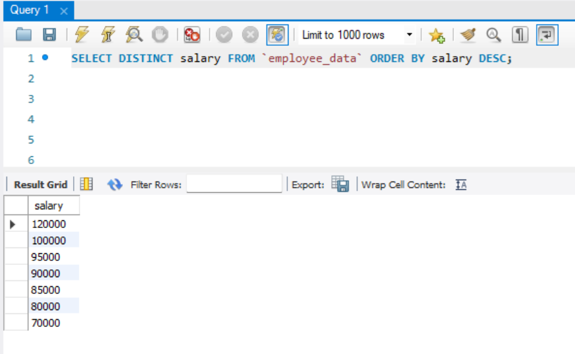
- How many District first names do we have in our database?
